UNIT 5
E COMMERCE
Ecommerce" or "electronic commerce" is the trading of goods and services on the internet.
E COMMERCE Security
Security is an essential part of any transaction that takes place over the internet. Customers will lose his/her faith in e-business if its security is compromised. Following are the essential requirements for safe e-payments/transactions −
- Confidentiality − Information should not be accessible to an unauthorized person. It should not be intercepted during the transmission.
- Integrity − Information should not be altered during its transmission over the network.
- Availability − Information should be available wherever and whenever required within a time limit specified.
- Authenticity − There should be a mechanism to authenticate a user before giving him/her an access to the required information.
- Non-Repudiability − It is the protection against the denial of order or denial of payment. Once a sender sends a message, the sender should not be able to deny sending the message. Similarly, the recipient of message should not be able to deny the receipt.
- Encryption − Information should be encrypted and decrypted only by an authorized user.
- Auditability − Data should be recorded in such a way that it can be audited for integrity requirements.

Measures to ensure Security
Major security measures are following −
- Encryption − It is a very effective and practical way to safeguard the data being transmitted over the network. Sender of the information encrypts the data using a secret code and only the specified receiver can decrypt the data using the same or a different secret code.
- Digital Signature − Digital signature ensures the authenticity of the information. A digital signature is an e-signature authenticated through encryption and password.
- Security Certificates − Security certificate is a unique digital id used to verify the identity of an individual website or user.

Nonrepudiation, message authentication code and digital signatures

Nonrepudiation is achieved through cryptography, like digital signatures, and includes other services for authentication, auditing and logging.

In online transactions, digital signatures ensure that a party cannot later deny sending information or deny the authenticity of its signature. A digital signature is created using the private key of an asymmetric key pair, which is public key cryptography, and verified with a corresponding public key.

Only the private key holder can access this key and create this signature, proving that a document was electronically signed by that holder. This ensures that a person cannot later deny that they furnished the signature, providing nonrepudiation.

In cryptography, a message authentication code (MAC), also known as a tag, is used to authenticate a message or confirm that the message came from the stated sender and was not changed along the way. Unlike digital signatures, MAC values are generated and verified using the same secret key, which the sender and recipient must agree on before initiating communications.

A MAC can protect against message forgery by anyone who doesn't know the shared secret key, providing both integrity and authentication. However, MAC algorithms, like cipher-based MAC and hash-based MAC, cannot provide nonrepudiation.

In addition to digital signatures, nonrepudiation is also used in digital contracts and email. Email nonrepudiation involves methods such as email tracking.

Drawbacks of nonrepudiation with digital signatures

Since no security technology is foolproof, some experts warn that a digital signature alone may not always guarantee nonrepudiation. Some suggest using multiple approaches to ensure nonrepudiation. One such practice is to capture biometric information and other data about the sender or signer that collectively would be difficult to repudiate.

It's also important to know that the current definitions of nonrepudiation in the digital space consider only the validity of the signature itself. They do not allow for the possibility that the signer was manipulated, forced or tricked into signing. It's also feasible that a virus, worm or other type of malware can compromise a sender's private key, possibly stealing or forging its digital signature and jeopardizing nonrepudiation.

Security Protocols in Internet
We will discuss here some of the popular protocols used over the internet to ensure secured online transactions.

Secure Socket Layer (SSL)
It is the most commonly used protocol and is widely used across the industry. It meets following security requirements −
- Authentication
- Encryption
- Integrity
- Non-reputability
"https://" is to be used for HTTP urls with SSL, where as "http:/" is to be used for HTTP urls without SSL.

Secure Hypertext Transfer Protocol (SHTTP)
SHTTP extends the HTTP internet protocol with public key encryption, authentication, and digital signature over the internet. Secure HTTP supports multiple security mechanism, providing security to the end-users. SHTTP works by negotiating encryption scheme types used between the client and the server.

Secure Electronic Transaction
It is a secure protocol developed by MasterCard and Visa in collaboration. Theoretically, it is the best security protocol. It has the following components −
- Card Holder's Digital Wallet Software − Digital Wallet allows the card holder to make secure purchases online via point and click interface.
- Merchant Software − This software helps merchants to communicate with potential customers and financial institutions in a secure manner.
- Payment Gateway Server Software − Payment gateway provides automatic and standard payment process. It supports the process for merchant's certificate request.
- Certificate Authority Software − This software is used by financial institutions to issue digital certificates to card holders and merchants, and to enable them to register their account agreements for secure electronic commerce.

Secret Key Cryptography
With secret-key cryptography, both communicating parties, Alice and Bob, use the same key to encrypt and decrypt the messages. Before any encrypted data can be sent over the network, both Alice and Bob must have the key and must agree on the cryptographic algorithm that they will use for encryption and decryption
One of the major problems with secret-key cryptography is the logistical issue of how to get the key from one party to the other without allowing access to an attacker. If Alice and Bob are securing their data with secret-key cryptography, and if Charlie gains access to their key, then Charlie can understand any secret messages he intercepts between Alice and Bob. Not only can Charlie decrypt Alice's and Bob's messages, but he can also pretend that he is Alice and send encrypted data to Bob. Bob won’t know that the message came from Charlie, not Alice.
After the problem of secret key distribution is solved, secret-key cryptography can be a valuable tool. The algorithms provide excellent security and encrypt data relatively quickly. The majority of the sensitive data sent in an TLS session is sent using secret-key cryptography.
Firewall
A Firewall is a network security device that monitors and filters incoming and outgoing network traffic based on an organization's previously established security policies. At its most basic, a firewall is essentially the barrier that sits between a private internal network and the public Internet.
Information Systems
Information system refers to various information technology systems like computers, software, database, communication systems, the internet, devices, and others used by an organization to collect, transfer, organize, and store data. Bursting with changes, the current business milieu has helped companies implement a varied set of advanced technologies into different processes. These IT applications have introduced automation, efficiency, and timeliness in various business activities.

The introduction of information systems into the business has evoked a chain reaction among different interrelated processes that have only benefited the companies by increasing profits and reducing costs and lead time, among other things. Therefore, it is imperative to understand the growing importance of information systems in companies.
Types Of Information Systems?
1. Knowledge Work System
There are different knowledge management systems that an organization implements to ensure a continuous flow of new and updated knowledge into the company and its processes. A knowledge work system (KWS) is one of the knowledge management systems that ease the integration of new information or knowledge into the business process.
Furthermore, KWS also offers support and resources to various knowledge creation techniques, artificial intelligence applications, and group collaboration systems for knowledge sharing, among others. It also uses graphics, visuals, etc., to disseminate new information. Below are some of the applications that work on the core fundamentals of KWS.
Designers often use computer-aided design systems (CAD) to automate their design process.
Financial workstations are used to analyze huge amounts of financial data with the help of new technologies.
Virtual reality systems are found in the scientific, education, and business fields for using graphics and different systems to present data.
2. Management Information System
The management information system provides aid to managers by automating different processes that were initially done manually. Business activities like business performance tracking and analysis, making business decisions, making a business plan, and defining workflow. It also provides feedback to the managers by analyzing the roles and responsibilities.
A management information system is considered a significant application that helps managers immensely. Here are some of the advantages of the information system:

It enhances the efficiency and productivity of the company
It provides a clear picture of the organization’s performance
It adds value to the existing products, introduces innovation and improves product development
It assists in communication and planning for business processes
It helps the organization provide a competitive advantage
3. Decision Support System
A decision support system is an information system that analyses business data and other information related to the enterprise to offer automation in decision-making or problem-solving. A manager uses it in times of adversities arising during the operation of the business. Generally, the decision support system is used to collect information regarding revenue, sales figures or inventory. It is used across different industries, and the decision support system is a popular information system.
4. Office Automation System
An office automation system is an information system that automates different administrative processes like documenting, recording data, and office transactions, among others. The office automation system is divided into managerial and clerical activities. Here are some of the business activities that are done under this type of information system
Email
Voice mail
Word processing
5. Transaction Processing System
The transaction processing system automates the transaction collection, modification, and retrieval process. The peculiar characteristic of this type of information system is that it increases the performance, reliability and consistency of business transactions. It helps businesses perform daily operations smoothly without hassle.
Once you are well-versed with different types of information systems, understanding the application of these systems becomes easy to comprehend. Therefore, in the last part of the article, we will look into applying information systems.
6. Executive Support System
An Executive Support System or ESS helps top-level executives to plan and control workflow and make business decisions. It is very similar to Management Information System or MIS.
Here are some of the unique characteristics of ESS:
It provides great telecommunication, better computing capabilities, and effective display options to executives.
It enables them with information through static reports, graphs, and textual information on demand.
It helps monitor performances, track competitors’ strategies, and forecast future trends, among others.
How To Apply Information Systems in Business?
Here are some of the business activities that require the intervention of an information system.
Enterprise resource planning (ERP)
Applying information systems to enterprise resource planning helps automate business administration and planning functions.
Supply chain management (SCM)
Information systems provide a common forum to connect with different parties in supply chain management. Moreover, it makes communication between parties easy and resourceful.
Customer relationship management (CRM)
Many information systems help in realizing customer requirements. Furthermore, other information applications help companies interact with their audience easily and hassle-free.

To understand the use of information technology and its ancillary systems, many business professionals pursue different courses. Emeritus India offers some of the best IT courses in partnership with various Indian and international institutes. So, enrol in our famous IT courses to accentuate your career.

Management
Management covers the planning, control, and administration of the operations of a concern. The top management handles planning; the middle management concentrates on controlling; and the lower management is concerned with actual administration.

Information
Information, in MIS, means the processed data that helps the management in planning, controlling and operations. Data means all the facts arising out of the operations of the concern. Data is processed i.e. recorded, summarized, compared and finally presented to the management in the form of MIS report.

System
Data is processed into information with the help of a system. A system is made up of inputs, processing, output and feedback or control.
Thus MIS means a system for processing data in order to give proper information to the management for performing its functions.

Definition
Management Information System or 'MIS' is a planned system of collecting, storing, and disseminating data in the form of information needed to carry out the functions of management.

Objectives of MIS
The goals of an MIS are to implement the organizational structure and dynamics of the enterprise for the purpose of managing the organization in a better way and capturing the potential of the information system for competitive advantage.
Following are the basic objectives of an MIS −
- Capturing Data − Capturing contextual data, or operational information that will contribute in decision making from various internal and external sources of organization.
- Processing Data − The captured data is processed into information needed for planning, organizing, coordinating, directing and controlling functionalities at strategic, tactical and operational level. Processing data means −
  - making calculations with the data
  - sorting data
  - classifying data and
  - summarizing data
- Information Storage − Information or processed data need to be stored for future use.
- Information Retrieval − The system should be able to retrieve this information from the storage as and when required by various users.
- Information Propagation − Information or the finished product of the MIS should be circulated to its users periodically using the organizational network.

Characteristics of MIS
Following are the characteristics of an MIS −
- It should be based on a long-term planning.
- It should provide a holistic view of the dynamics and the structure of the organization.
- It should work as a complete and comprehensive system covering all interconnecting sub-systems within the organization.
- It should be planned in a top-down way, as the decision makers or the management should actively take part and provide clear direction at the development stage of the MIS.
- It should be based on need of strategic, operational and tactical information of managers of an organization.
- It should also take care of exceptional situations by reporting such situations.
- It should be able to make forecasts and estimates, and generate advanced information, thus providing a competitive advantage. Decision makers can take actions on the basis of such predictions.
- It should create linkage between all sub-systems within the organization, so that the decision makers can take the right decision based on an integrated view.
- It should allow easy flow of information through various sub-systems, thus avoiding redundancy and duplicity of data. It should simplify the operations with as much practicability as possible.
- Although the MIS is an integrated, complete system, it should be made in such a flexible way that it could be easily split into smaller sub-systems as and when required.
- A central database is the backbone of a well-built MIS.

Characteristics of Computerized MIS
Following are the characteristics of a well-designed computerized MIS −
- It should be able to process data accurately and with high speed, using various techniques like operations research, simulation, heuristics, etc.
- It should be able to collect, organize, manipulate, and update large amount of raw data of both related and unrelated nature, coming from various internal and external sources at different periods of time.
- It should provide real time information on ongoing events without any delay.
- It should support various output formats and follow latest rules and regulations in practice.
- It should provide organized and relevant information for all levels of management: strategic, operational, and tactical.
- It should aim at extreme flexibility in data storage and retrieval.

Nature and Scope of MIS
The following diagram shows the nature and scope of MIS −
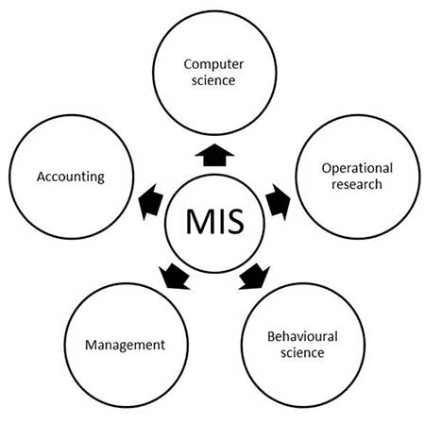
Decision support systems
(DSS) are interactive software-based systems intended to help managers in decision-making by accessing large volumes of information generated from various related information systems involved in organizational business processes, such as office automation system, transaction processing system, etc.
DSS uses the summary information, exceptions, patterns, and trends using the analytical models. A decision support system helps in decision-making but does not necessarily give a decision itself. The decision makers compile useful information from raw data, documents, personal knowledge, and/or business models to identify and solve problems and make decisions.

Characteristics of a DSS
- Support for decision-makers in semi-structured and unstructured problems.
- Support for managers at various managerial levels, ranging from top executive to line managers.
- Support for individuals and groups. Less structured problems often requires the involvement of several individuals from different departments and organization level.
- Support for interdependent or sequential decisions.
- Support for intelligence, design, choice, and implementation.
- Support for variety of decision processes and styles.
- DSSs are adaptive over time.

Benefits of DSS
- Improves efficiency and speed of decision-making activities.
- Increases the control, competitiveness and capability of futuristic decision-making of the organization.
- Facilitates interpersonal communication.
- Encourages learning or training.
- Since it is mostly used in non-programmed decisions, it reveals new approaches and sets up new evidences for an unusual decision.
- Helps automate managerial processes.

Components of a DSS
Following are the components of the Decision Support System −
- Database Management System (DBMS) − To solve a problem the necessary data may come from internal or external database. In an organization, internal data are generated by a system such as TPS and MIS. External data come from a variety of sources such as newspapers, online data services, databases (financial, marketing, human resources).
- Model Management System − It stores and accesses models that managers use to make decisions. Such models are used for designing manufacturing facility, analyzing the financial health of an organization, forecasting demand of a product or service, etc.
Support Tools − Support tools like online help; pulls down menus, user interfaces, graphical analysis, error correction mechanism, facilitates the user interactions with the system.

Expert system
An expert system is a computer program that uses artificial intelligence (AI) technologies to simulate the judgment and behavior of a human or an organization that has expertise and experience in a particular field. Expert systems are usually intended to complement, not replace, human experts.
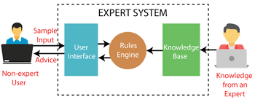

Office Automation Systems
Office automation is the process of watching data flow around on its own without any human intervention, inaccuracies, and errors. It is the process of using an automation tool to create, collect, store, analyze, and share confidential office data that is required to accomplish basic day-to-day routine tasks and processes effectively.
Technology has made a serious impact on the daily work of office administration. Emails have replaced memos, shared drives have done away with filing cabinets, and biometrics have taken over employee timesheet stamping. Many businesses think that they have attained office automation nirvana simply by going paperless.
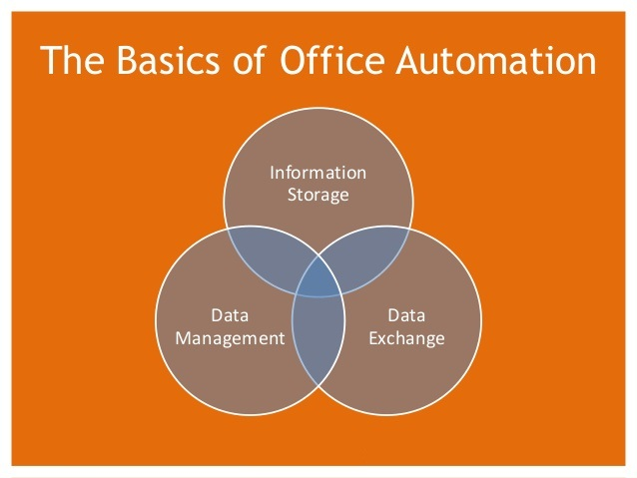
An office automation system is a mechanism that allows data transformation from one system to another on its own without human interference and inaccuracies. These tools may be used to capture, organize, and process the data to achieve day-to-day activities. It is an automated process, explicitly supporting business activities and processes. Office automation is intended to provide elements that make it possible to simplify, develop, and automate the organization of the activities of a company or a group of people.
A basic building block of Office Automation Systems described below –
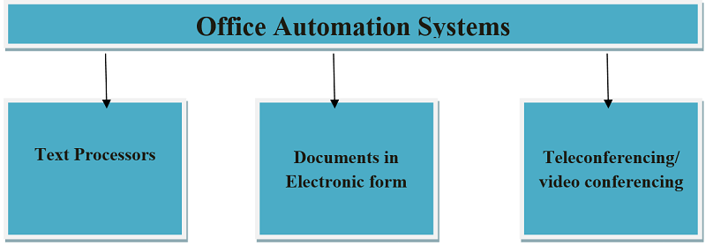
Office automation systems make it simple for office staff to handle day to day organizational activities like E-mail, word processing, electronic filing, scheduling, calendaring, and other technical support resources. Personal digital assistants (PDAs) were also introduced as the concept of groupware apps, which became important when more people started to bring digital assistants such as PDAs. It is made up of word processing, telecommunications, and data processing, which handles office information, official communication, and reports, as well as the processing of documents.
The most commonly used application areas of office automation are as follows -
- Exchange of information.
- Management of administrative records.
- Handling of results.
- Meeting arrangements, preparation, and control of job schedules.

Office automation features
Office automation functionality could include -.
- It eliminates the manual effort to complete basic chores.
- Avoiding mistakes by computers or devices.
- Decreasing the time taken to process an object.
- Provides key insights into the process efficiency metrics.
- Gaining greater access to the method and finding possible bottlenecks.
- Controlling the company by making sound decisions based on results.
- Enhancement in business activities with sound improvement.
- Data organization, storage and its management.

Computer technology has been a part of the business world for decades. It’s not just a fad or something that will go away – computing and its applications are here to stay. In fact, it’s only growing in importance as businesses become more reliant on their networks and partners.
Computer systems are used throughout all types of organizations, from small businesses to corporations with international reach. There are many ways computer technology can make your business more efficient and increase your bottom line.
Computers are the most powerful and cost-efficient technology that businesses can use to streamline workflow, boost productivity, and eliminate waste. From smartphones and tablets to desktop computers, laptops, and virtual assistants, the digital age has transformed how we access information and conduct business.

Electronic Data Storage
As technology continues to advance, the amount of data being generated is also growing exponentially. This data includes the information used to run businesses and the data generated by customers and employees.
When paper records were the primary way of storing information, it was relatively simple to find a specific document or record. However, when the amount of information is in the millions of items, it can become extremely time-consuming to find a specific piece of paper.

Electronic Communication
Communication within the business world has changed dramatically since the early days of the telephone and telex (a type of telecommunication device). Today, businesses communicate electronically via email, text messaging, and videoconferencing.
This technology has replaced many of the personal communication methods that were once common in business. Instead of sending a letter or making a long-distance phone call, a business owner can send a quick email message to a supplier or employee

Computer-Based Staffing
Using computers to assist in staffing decisions can help businesses find the right candidates for positions faster, more efficiently, and with fewer human resources staff members. Computer programs can scan an organization’s employment data and compile a list of candidates who meet a job candidate’s qualifications.

Business Software
Business software is designed to enable companies of all types to run more efficiently and increase productivity. This software can be purchased in the form of computer programs or as services provided by third-party vendors. Each type of software is designed to address a specific business need.

Computer Related Jobs

The fast computerization of every work and gradual dependency on computer based work has exponentially opened a new arena of Information technology for employment.
However, the IT field requires qualified and trained employees who can design and develop a new information system.
Information technology has also helped in research and development and has further developed new technologies. The IT employees emphasize on planning, designing, developing, managing the work, and providing technical support to various users.

Types of Computer Related Jobs
In recent times, a number of jobs have come up that are done with the assistance of computer. We will discuss the different job titles performing computer related jobs −

Programmer
A person who is qualified enough to write a creative code for the computer program is known as Programmer.
The codes written by programmer are the instructions given to the computer over what to do, how to do, when to do, etc.

System Analyst
The job of a system analyst is highly classified and also very crucial.
A system analyst fundamentally designs, develops, and implements new systems or adds some additional features in the existing system to give instructions to perform additional tasks.
System analyst also specializes in fields such as engineering, science & technology, finance, business, accounting, etc.

Database Administrator
A database administrator or simply DBA is a trained person who is accountable for the storage of and management of the database system.

Network Administrator
Computer networking is another specialized field where a qualified person is required.
A network administrator specializes in installing, configuring, and supporting computer network system. Likewise, he manages the local area network, wide area network, the Internet system or the segment of a network system in the respective organization.
The job of a network administrator is a very crucial one as almost every network in an organization requires at least one network administrator.

Web Designers
A web designer is an architect who designs an effective and communicative website.
He places the images, contents, and other such information on right places to make the website interactive and user friendly.

Information Security Analysts
This is one of the most significant jobs under which an Information Security Analyst designs, implements, and supports the security system of a computer or whole network.

